**Ideation Phase**

**Define the Problem Statements**

|  |  |
| --- | --- |
| Date | 30 October 2025 |
| Team ID | NM2025TMID00370 |
| Project Name | Streamlining Ticket Assignment for Efficient Support Operations |
| Maximum Marks | 2 Marks |

**Customer Problem Statement Template:**

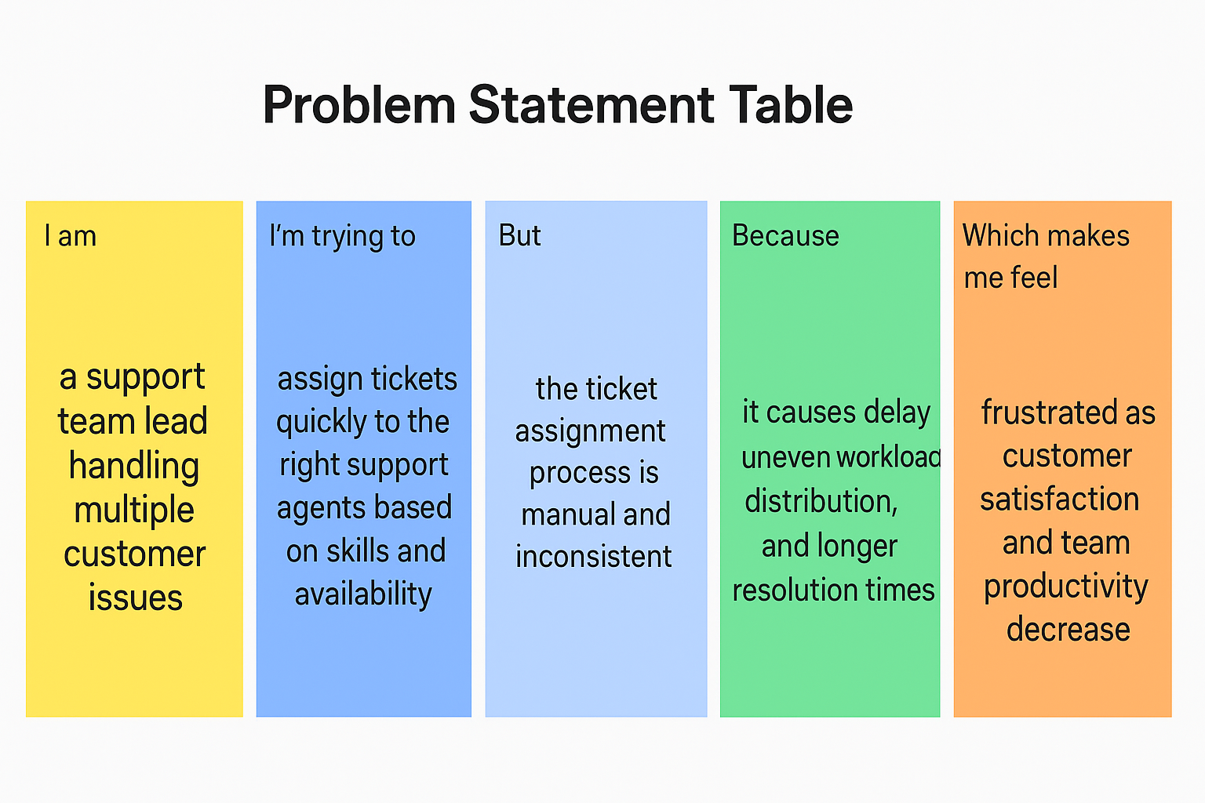

## Problem Statement Table:

|  |  |  |  |  |  |
| --- | --- | --- | --- | --- | --- |
| Problem Statement (PS) | I am (Customer) | I’m trying to | But | Because | Which makes me feel |
| PS-1 | a support team lead handling multiple customer issues | assign tickets quickly to the right support agents based on skills and availability | the ticket assignment process is manual and inconsistent | it causes delays, uneven workload distribution, and longer resolution times | frustrated as customer satisfaction and team productivity decrease |
| PS-2 | a support agent receiving new customer tickets | get tickets that match my expertise and workload fairly | I often get assigned unrelated or excessive tickets | the system lacks automation and intelligent ticket routing | overwhelmed and demotivated due to inefficient workload management |